Create a new React Application with the name “myfirstreact”, Run the application to print “welcome to the first session of React” as heading of that page.

**App.js**:

function App(){

  const styles = {textAlign: "center",}

  return(

    <h1 style={styles}>Welcome the first session of React</h1>

  );

}

export default App;

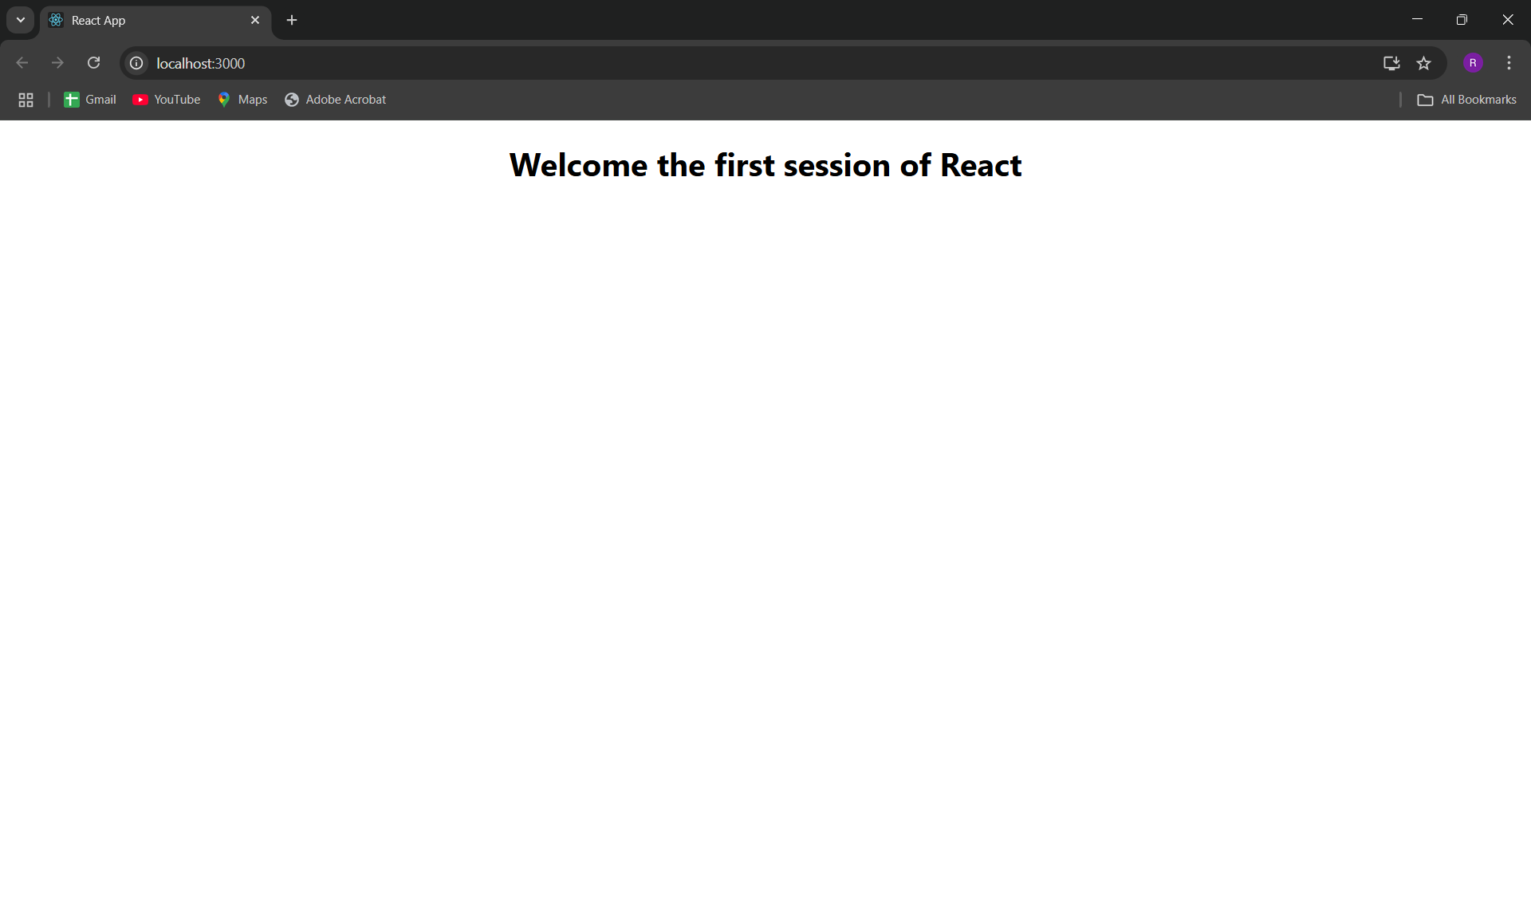**OUTPUT:**